SDA 4 and 5 Rollback Testing
The following scenario assumes that an application and its associated component has already been defined, and has been used for deployments.

The following four steps will give an overview of how an existing application can be configured.

Step 1: Ensure that the Inventory Management is set to Advanced
In order to use rollback steps in an application process, the inventory management needs to be changed from the default of Automatic to Advanced.
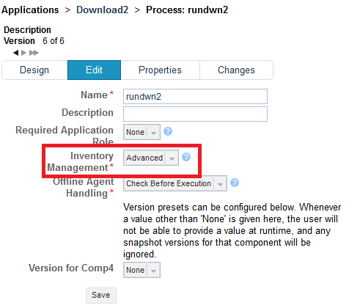
Otherwise the following error message may appear when request a process application
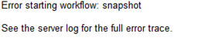

Step 2: Define two processes for the component
Two processes should be defined one that performs the deployment and a diagnostic test and one that simply deploys the artefacts.

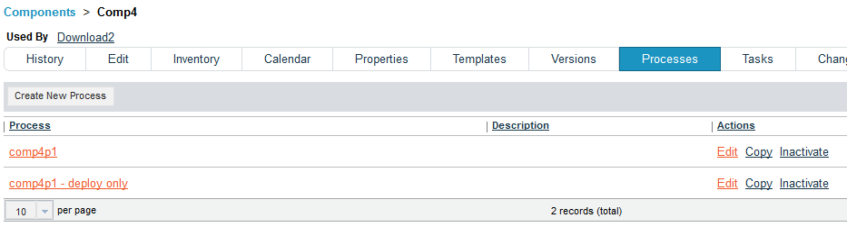
This is the Comp4p1 process which contains the download and diagnostic step
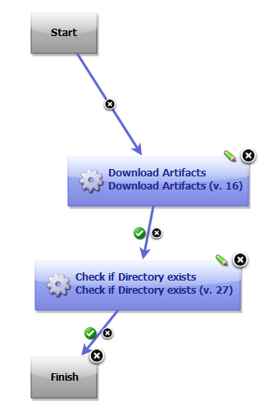rbRun

Here is the Check Directory if Directory exists step, which simply checks for the presence of a directory
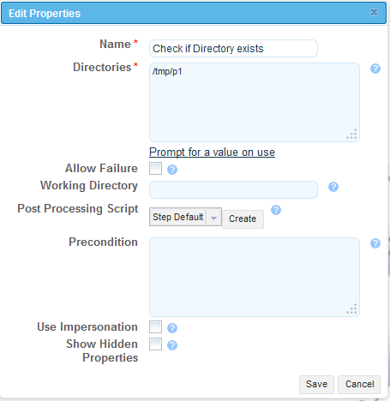

This is the Comp4p1 – deploy only process which contains just the download step
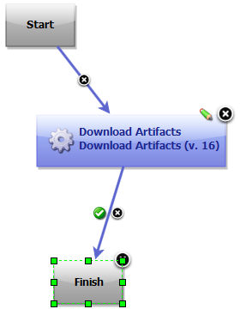

Step 3: Define the Application Process Logic
Go to Applications>Example Application>Process: App Process Logic
The Application Process contains the following logic
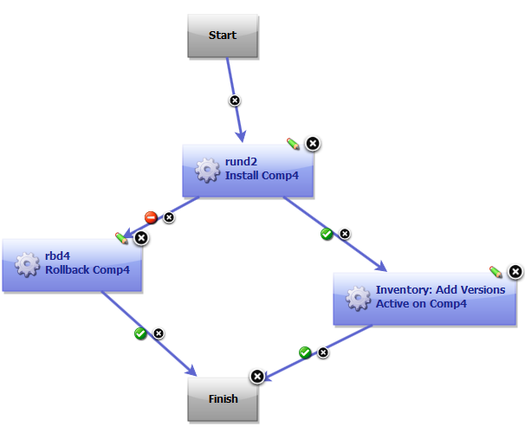

Note: The Inventory Add Versions step ensures that the version is added to the request inventory should the component install correctly.

The rund2 step calls the Comp4p1 component process
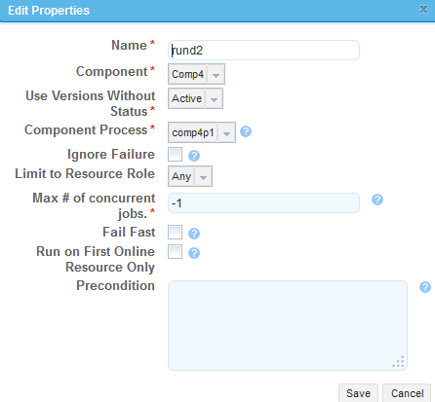

The rbd4 step calls the Comp4p1 – deploy only component process.
The Rollback Type must set to Replace with Last Deployed.
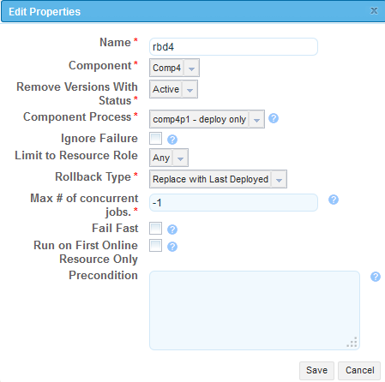
Note: In order to remove files that were created in the version to be rolled back, the comp4p1 – deploy only process Sync Mode needs to be changed to Sync and Clean, as shown below
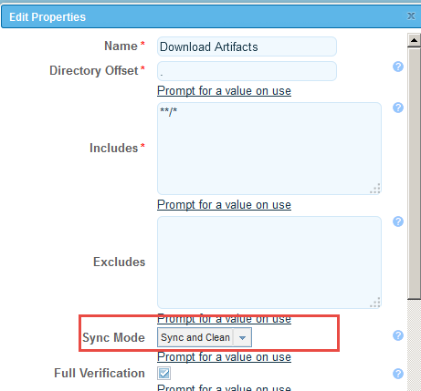

Step 4: Test the rollback and success scenarios
The component contains two versions V1 and V2

Rollback Test
- Ensure directory exists for second diagnostic step
- Request V1
- V1 is deployed and second diagnostic step is successful
- Remove directory for second diagnostic step
- Request V2
- V2 is deployed and second step FAILS
- Rollback step is executed
- V1 is deployed

Rollback not required test
- Ensure directory exists for second diagnostic step
- Request V1
- V1 is deployed and second diagnostic step is successful
- Remove directory for second diagnostic step
- Request V2
- V2 is deployed and second step is successful

